Rules of Riding the Bus  Do as the Bus Driver asks- the first time!  Keep your body (hands & feet), and property to yourself!  Sit with your back against the seat!  Talk in your classroom voice!  Remain in your seat while on the bus and DO NOT get out of your seat UNTIL the bus is completely stopped at YOUR bus stop! |  | PARENT RESPONSIBILITIES  - To ensure that your child arrives at the correct bus stop 5 minutes before scheduled bus arrival time  - To provide necessary protection for your child when going to and from the bus stop  - To accept joint responsibility with school authorities for proper conduct of your child while riding the bus and at the bus stop  - To be sure that your child is properly dressed for the weather  - To make a reasonable effort to understand and cooperate with those responsible for pupil transportation  - To explain to your child that a bus may take a different route than they are used to on occasion and not to be upset. They will arrive at their bus stop or school. |  | NORTONCITY SCHOOLS  - Transportation Department  - 330-825-2226  The Norton Schools Transportation Department would like to welcome you and your child. We take great pride in our transportation department and Safety is our #1 goal.  Please remember that if you change your phone number, to let the Transportation Department know as well as the school that your child attends.  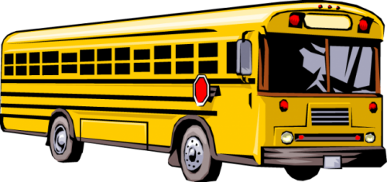  - 330-825-2226

Rules for the Bus Stop  - Students need to be at their bus stop 5 minutes before the scheduled pickup time and ready to load- NOT waiting in vehicles or in house or porch when the bus arrives. The reason for this is the safety of your student and to keep the bus on their time schedule.  - Students crossing the road to get on the bus shall cross in front of the bus and obey the drivers hand signal- again this is for the safety of your child.  - Students are not allowed to switch bus stops if they are late.  - Students are asked to respect the surrounding property at the bus stop, such as mailboxes, grass, or landscaping while waiting for the bus and to leave the bus stop location clean of any litter.  - Students must get on and off at your assigned stop and wait at your Designated Place of Safety set by the bus driver. |  | Behavior on the Bus  - The bus driver is in charge.  - Students will be seated as directed by the driver and will be assigned a seat.  - Students need to be seated as quickly as possible upon entering the bus.  - Students, (at times), may be required to sit three (3) to a seat.  - Do not get out of your seat while the bus is moving. You may only switch seat with permission of the driver.  - Only bring items on the bus that you can hold in your lap. (No balloons, glass, or animals)  - Items not allowed in school are not allowed on the bus. This list includes skateboards and roller blades.  - Cell phone use is not permitted. Some drivers may let you use it for music or games only, with only 1 earbud in. Absolutely no pictures or videotaping.  - Keep bus aisle and emergency exits clear at all times.  - Foul or inappropriate language is never allowed.  - Yelling, loud voices or horseplay is not permitted on the bus.  - Eating, drinking, or chewing gum on the bus is not permitted.  - Help keep the bus clean. Put all trash in the trash can. |  | Consequences  - Students violating the rules of the bus may receive a “white card”. These cards are given to the school office.  - A student that continues to violate the bus rules may be suspended from the bus. – Riding the bus is a privilege NOT a right!  Other Information  - It is possible, due to routing issues, your students bus #, times, or pick up/ drop off location may change at any time during the school year.  - Remember bus times are approximate and may change without notice according to bus loads each day.  - Your child’s bus stop must be the same location 5 days a week. Morning pick up and afternoon drop off locations may be different.  Our buses have yellow lights as well as red lights. Remember YELLOW means slow down and be prepared to STOP. RED means stop.

